**Sustainability Goals 2024**

Harmac Medical Products has locations in three different countries. While our customer, employee and community needs are varied in each of these geographies, one thing is the same, our commitment to look after the environment for future generations. Harmac will continue to utilize the framework created by the United Nations to work towards **Good Health and Well-Being, Sustainable Cities and Communities** and **Responsible Consumption and production** at each of our locations.

**Good Health and Well-Being**

Encourage healthy habits with a walking challenge, blood pressure monitoring, and onsite education programs for healthy living.

**Sustainable Cities and Communities**

Support local charities and community clean up events. Train employees in CPR and First Aid to assist in emergencies and support local first responders.

**Responsible Consumption and production**

Begin tracking scope 1 & 2 emissions data to understand our carbon footprint and to create baseline data for future projects.

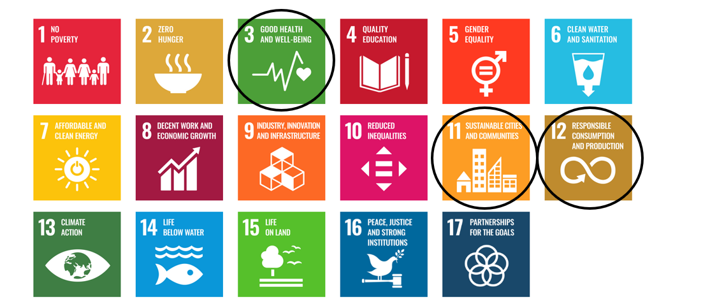

**Harmac’s 2023 Sustainability Achievements**

*Good Health and Well-Being*

* Employees from each facility competed in the 3rd Annual walking challenge. We had 68 people walk over 21 million steps in one month!
* Offered employees a variety of onsite programs and information on mental health, cancer awareness and overall well-being. This included a Maintain Don’t Gain Challenge for employees to maintain their weight from November to January.

*Sustainable Cities and Communities*

* Supported charities local to each facility. This included the Hospice flower sale, FeedMore WNY food collection, Camp Good Days electronic scrap collection, Vita House financial donation, and STEAM education through mentorship.
* Annual College scholarship program for children/grandchildren of Harmac employees. In the past 10 years, 39 scholarships have been awarded.

*Responsible Consumption and Production*

* Continued conversion of mold machines to energy efficient models in Buffalo.
* Continue conversion to energy efficient LED lighting, Buffalo has completed 85% and Castlerea has completed 100% of the facility.
* Castlerea completed 5 energy savings projects for a total CO2 savings of 112 tons per year.

**Harmac’s Previous Sustainability Achievements**

* Provided on-site First Aid Training to employee volunteers in Buffalo & Castlerea, 2022.
* Added Blood Pressure Kiosk for self-monitoring in Buffalo, 2022.
* 2022: Supported charities local to each facility, including Hospice, FeedMore WNY, Camp Good Days, BUMBLEance, and STEAM education.
* 2022: Partnered with local non-profits for workforce development and apprentice programs in Buffalo.
* Replaced facility compressor with energy efficient upgrade in Buffalo, 2022
* Achieved Zero Waste to Landfill at Castlerea facility, 2022 & 2023.
* Employees from each facility competed in a walking challenge, with Castlerea earning the trophy for 2021.
* Offered on-site vaccine clinics for employees and family members at all 3 sites – 2021.
* Assist with public or communal transportation for employees in Buffalo and Tijuana.
* Replaced two injection mold machines with new equipment to improve efficiency. Old equipment was repurposed and kept out of landfill. (Buffalo) -2021
* Updated Air Handler Unit to improve efficiency, reducing energy for air handling by 17% (Castlerea) -2021
* Installed water saving equipment in all facility restrooms (Tijuana) - 2021
* Added thermal camera screening at all facility entrances, plexiglass shields, updated workstation layouts, changed work schedules for social distancing at all 3 sites -2020
* Added cleaning and disinfecting staff, and sanitizing stations at all 3 sites-2020
* Provided food, masks, gloves and financial donations to people and organizations in need in Buffalo, Tijuana and Castlerea-2020
* All manufacturing clean rooms converted to LED lighting in Buffalo, NY – 2019
* Implemented composting program in Buffalo, NY in 2018
* Reduced "Sharps" waste by 5% in Buffalo, NY in 2018
* Reduced energy consumption by an additional 5% in Castlerea, Ireland in 2018
* Converted 1 of 3 clean rooms to LED lighting in Buffalo, NY in 2017
* Reduced cost of electricity per unit of sales by 33.6% in Castlerea, Ireland in 2017
* Increased plastic recycling to 46% in Buffalo, NY in 2016
* Reduced energy consumption by 5% in Castlerea, Ireland in 2016
* 15% reduction in cost of electricity per unit of sales in Castlerea, Ireland in 2015
* Achieved ISO 14001 certification at Harmac HQ in Buffalo, NY
* Replaced street lights adjacent to facility with LED versions in coordination with the Town of Castlerea to decrease power usage. October 2013
* Utilize hydroelectric generated power for 10% of our needs at Harmac HQ in Buffalo, NY. September 2012
* Donated new fitness center to the Town of Castlerea for use by our employees and the town residents. June 2012
* 14001 certified in our Castlerea, Ireland facility. November 2011